# **Lab - Creating Amazon EC2 Instances**

Traditional methods of deploying servers and configuring security are complex and often involve multiple teams and long delays. Fortunately, it is quick and easy to deploy secure infrastructure in the cloud. As a Systems Operator, you can automate many of these processes using the AWS Command-Line Interface.

In this lab you will:

* Launch an Amazon EC2 instance using the management console
* Launch an Amazon EC2 instance using the AWS Command-Line Interface (AWS CLI)

The final architecture will be:

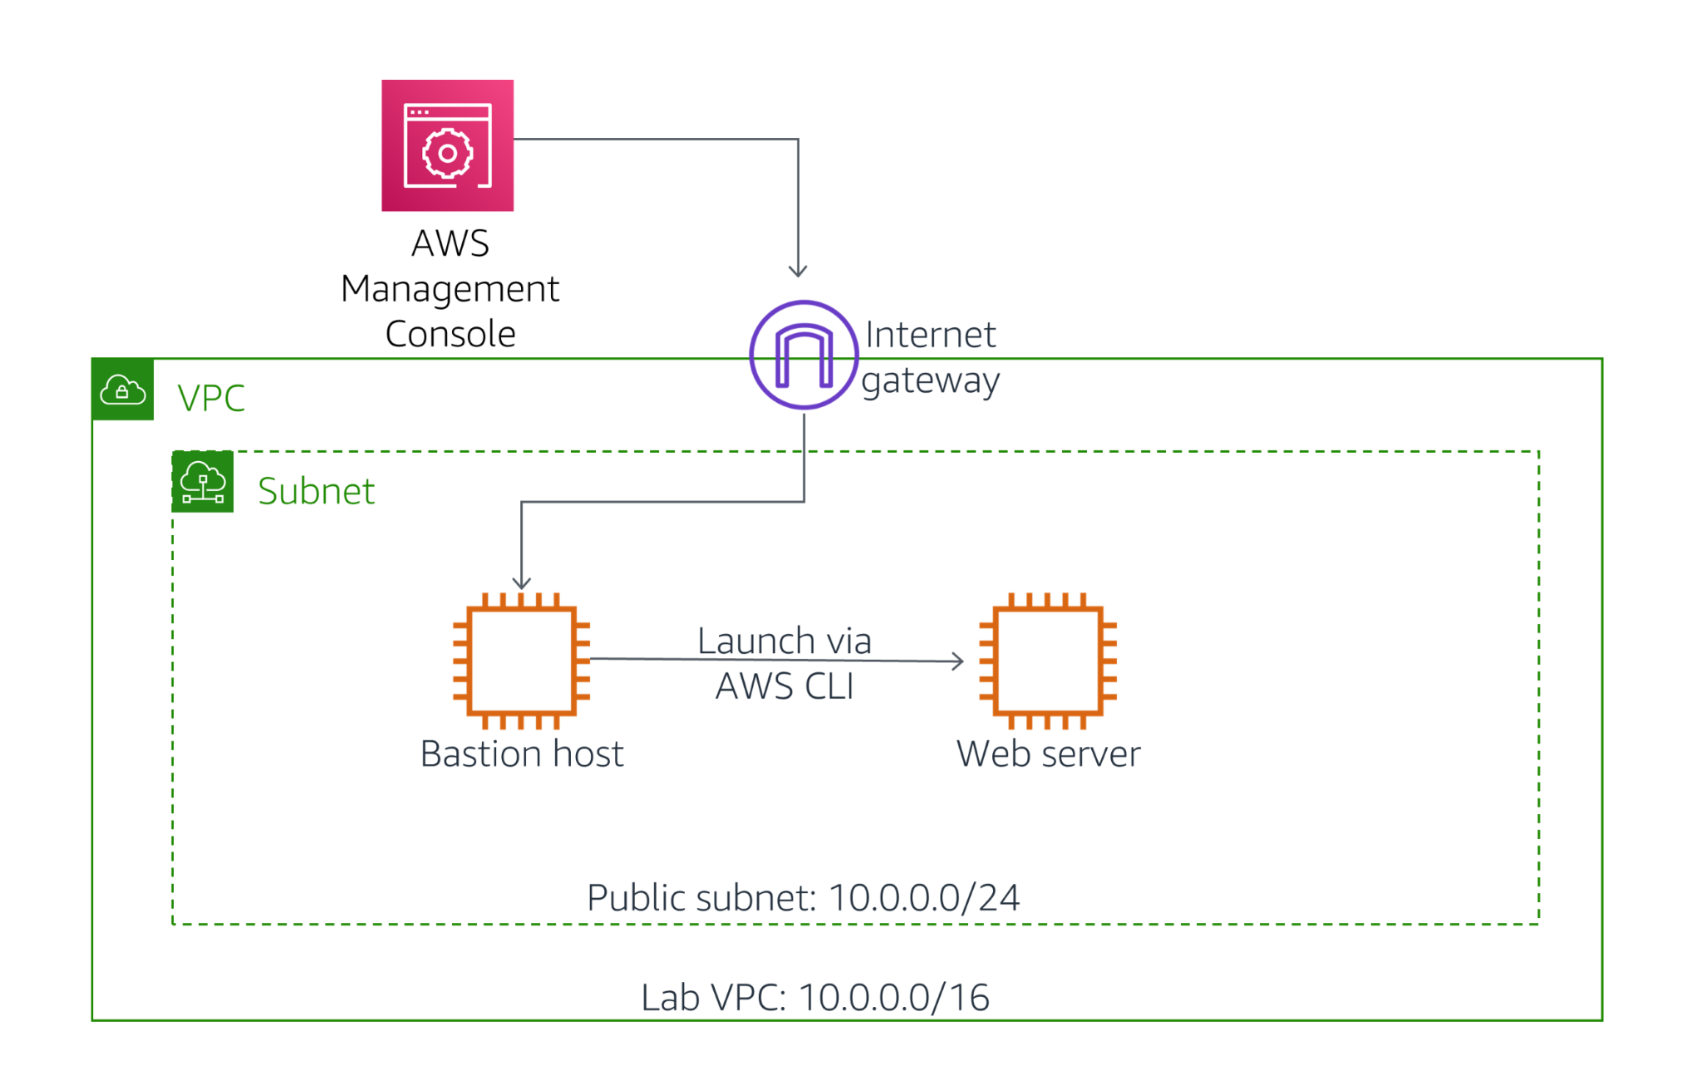

If you have time, an **optional Challenge section** will then have you troubleshoot some issues with Amazon EC2 instances.

## **Duration**

This lab will require approximately **45 minutes** to complete.

## **Accessing the AWS Management Console**

1. At the top of these instructions, click Start Lab to launch your lab.  
   A Start Lab panel opens displaying the lab status.
2. Wait until you see the message "**Lab status: ready**", then click the **X** to close the Start Lab panel.
3. At the top of these instructions, click AWS  
   This will open the AWS Management Console in a new browser tab. The system will automatically log you in.  
   **Tip**: If a new browser tab does not open, there will typically be a banner or icon at the top of your browser indicating that your browser is preventing the site from opening pop-up windows. Click on the banner or icon and choose "Allow pop ups."
4. Arrange the AWS Management Console tab so that it displays along side these instructions. Ideally, you will be able to see both browser tabs at the same time, to make it easier to follow the lab steps.  
    Please do not change the Region during this lab.

## **Task 1: Launch an Amazon EC2 Instance using the Management Console**

In this task, you will launch an Amazon EC2 instance using the management console. The instance will be a Bastion Server, from which you can use the AWS Command-Line Interface (AWS CLI).

1. In the **AWS Management Console**, on the **Services** menu, click **EC2**.
2. Click **Launch Instance**

### **Step 1: Choose an Amazon Machine Image (AMI)**

This step allows you to choose an AMI, which contains a copy of the disk volume that will be used to launch the instance.

Examine the list of AMIs that are displayed, showing many versions of Microsoft Windows and Linux. These disk images are regularly updated to incorporate security patches and software that helps you use AWS services. You can also create your own AMI that includes your own data and applications, or you can select pre-built commercial applications from the **AWS Marketplace**.

Your Bastion Server will use *Amazon Linux 2*.

1. Beside the **Amazon Linux 2 AMI** (at the top), click **Select**

### **Step 2: Choose an Instance Type**

This step allows you to choose an **Instance Type**, which determines the resources that will be allocated to your EC2 instance. Each Instance Type allocates a combination of virtual CPUs, memory, disk storage and network performance.

Instance Types are divided into **families** such as Compute-optimized, Memory-optimized and Storage-Optimized. The name of the Instance Type includes a family identifier, such as **t3** and **m5**. The number indicates the *generation* of the instance, so **m5** is newer than **m4**.

Your application will use a **t3.micro** Instance Type, which is a small instance that can burst above baseline performance when it is busy. It is ideal for development, testing and for applications that have bursty workloads.

1. Select **t3.micro**
2. Click **Next: Configure Instance Details**

### **Step 3: Configure Instance Details**

This step allows you to configure instance details, such as the number of instances to launch and the network configuration. You can hover over the icons to view a description of each field.

You will launch the instance in a public subnet within the *Lab VPC* network.

1. Configure these settings:
   * **Network:** *Lab VPC*
   * **Subnet:** *Public Subnet*
   * **IAM role:** *Bastion-Role*
2. The *Bastion-Role* grants permission to applications running on the instance to make requests to the Amazon EC2 service. This is required for the second half of this lab, where you will use the AWS CLI to communicate with the EC2 service.
3. Click **Next: Add Storage**

### **Step 4: Add Storage**

This step can be used to add additional Amazon Elastic Block Store (EBS) disk volumes and configure their size and performance.

You can hover over the icons to view a description of each field.

You will use the default disk size, so no changes are required.

1. Click **Next: Add Tags**

### **Step 5: Add Tags**

Tags allow you to categorize your AWS resources in different ways, such as by purpose, owner, or environment. This is useful when you have many resources of the same type — you can quickly identify a specific resource by their tags. Each tag consists of a *Key* and a *Value*, both of which you define.

1. Click **Add Tag** then configure:
   * **Key:** Name
   * **Value:** Bastion Server
2. This name will appear on the instance in the EC2 management console.
3. Click **Next: Configure Security Group**

### **Step 6: Configure Security Group**

You will create a new Security Group that permits SSH connections. This security group will allow you to log in to the Bastion Server via SSH.

1. Configure these settings:
   * **Security group name:** Bastion security group
   * **Description:** Permit SSH connections
2. Permissions for inbound access via SSH (port 22) have already been configured by default.
3. Click **Review and Launch**

### **Step 7: Review Instance Launch**

This step displays a summary of the configuration for the instance you are about to launch.

1. Click **Launch**A **Select an existing key pair or create a new key pair** window will appear.
2. Select **I acknowledge that...**.
3. Click **Launch Instances**Your instance will now be launched.
4. Click **View Instances**The Bastion Server will appear in a *pending* state, which means it is being launched. It will then change to *running*, which indicates that the instance has started booting.
5. Wait for the **Instance State** to change to **running**.
6. Select **Bastion Server**.  
   Review the information displayed in the **Description** tab in the lower half of the page. It includes information about the instance type, security settings and network settings.

## **Task 2: Log into the Bastion Server**

In this task, you will log into the Bastion Server that you just created.

1. Copy the **IPv4 Public IP** (shown in the lower half of the page) to your clipboard.  
    It might take a minute until the *IPv4 Public IP* value is displayed.  
   The following instructions now vary slightly depending on whether you are using Windows or Mac/Linux.

### **Windows Users: Using SSH to Connect**

These instructions are for Windows users only.

If you are using macOS or Linux, [skip to the next section](https://labs.vocareum.com/web/1469070/423569.0/ASNLIB/public/docs/lang/en/README.html#ssh-MACLinux).

1. Read through the three bullet points in this step before you start to complete the actions, because you will not be able see these instructions when the Details panel is open.
   * Click on the Details drop down menu above these instructions you are currently reading, and then click Show. A Credentials window will open.
   * Click on the **Download PPK** button and save the **labsuser.ppk** file. Typically your browser will save it to the Downloads directory.
   * Then exit the Details panel by clicking on the **X**.
2. Download needed software.
   * You will use **PuTTY** to SSH to Amazon EC2 instances. If you do not have PuTTY installed on your computer, [download it here](https://the.earth.li/~sgtatham/putty/latest/w64/putty.exe).
3. Open **putty.exe**
4. Configure PuTTY to not timeout:
   * Click **Connection**
   * Set **Seconds between keepalives** to 30
5. This allows you to keep the PuTTY session open for a longer period of time.
6. Configure your PuTTY session:
   * Click **Session**
   * **Host Name (or IP address):** Paste the **IPv4 Public IP** value you copied to your clipboard earlier in the lab.
   * Back in PuTTy, in the **Connection** list, expand **SSH**
   * Click **Auth** (don't expand it)
   * Click **Browse**
   * Browse to and select the lab#.ppk file that you downloaded
   * Click **Open** to select it
   * Click **Open**
7. Click **Yes**, to trust the host and connect to it.
8. When prompted **login as**, enter: ec2-user  
   This will connect you to the EC2 instance.
9. [Windows Users: Click here to skip ahead to the next task.](https://labs.vocareum.com/web/1469070/423569.0/ASNLIB/public/docs/lang/en/README.html#ssh-after)

### **Mac and Linux Users**

These instructions are for Mac/Linux users only. If you are a Windows user, [skip ahead to the next task.](https://labs.vocareum.com/web/1469070/423569.0/ASNLIB/public/docs/lang/en/README.html#ssh-after)

1. Read through the three bullet points in this step before you start to complete the actions, because you will not be able see these instructions when the Details panel is open.
   * Click on the Details drop down menu above these instructions you are currently reading, and then click Show. A Credentials window will open.
   * Click on the **Download PEM** button and save the **labsuser.pem** file.
   * Then exit the Details panel by clicking on the **X**.
2. Open a terminal window, and change directory cd to the directory where the labsuser.pem file was downloaded.  
   For example, run this command, if it was saved to your Downloads directory:

cd ~/Downloads

1. Change the permissions on the key to be read only, by running this command:

chmod 400 labsuser.pem

1. Return to the terminal window and run this command (replace **<public-ip>** with the **IPv4 Public IP** value you copied to your clipboard earlier in the lab):

ssh -i labsuser.pem ec2-user@<public-ip>

1. Type yes when prompted to allow a first connection to this remote SSH server.  
   Because you are using a key pair for authentication, you will not be prompted for a password.

Now that you are connected to the Bastion Server, you can use the AWS CLI to call AWS services.

## **Task 3: Launch an Instance using the AWS CLI**

In this task, you will launch an Amazon EC2 instance using the AWS Command-Line Interface (CLI). The AWS CLI makes it easy to automate the provision and configuration of AWS resources.

The new instance will be configured as a Web Server.

### **Obtain the AMI to Use**

One of the parameters required when launching an instance is the Amazon Machine Image (AMI), which will populate the boot disk of the instance. AMIs are continually patched and updated by AWS, so it is recommended to always use the latest AMI when launching instances.

You will use the **AWS Systems Manager Parameter Store** to obtain the ID of the most recent *Amazon Linux 2* AMI. AWS maintains a list of standard AMIs in the Parameter Store, making this task easy to automate.

1. Paste this script into your PuTTY/ssh session:

# Set the Region  
AZ=`curl -s http://169.254.169.254/latest/meta-data/placement/availability-zone`  
export AWS_DEFAULT_REGION=${AZ::-1}  
# Obtain latest Linux AMI  
AMI=$(aws ssm get-parameters --names /aws/service/ami-amazon-linux-latest/amzn2-ami-hvm-x86_64-gp2 --query 'Parameters[0].[Value]' --output text)  
echo $AMI

1. This command did the following:
   * Obtained the Region where the instance is running
   * Called the AWS Systems Manager (*ssm*) and used the **get-parameters** command to retrieve a value from the Parameter Store
   * The AMI requested was for Amazon Linux 2 (*amzn2-ami*)
   * The AMI ID has been stored in an Environment Variable called *AMI* If your SSH session disconnects, it will lose the information stored in environment variables. Once you reconnect, you will need to re-run all of the steps in this task, starting with the above commands to obtain the AMI ID.

### **Obtain the Subnet to Use**

You will be launching the new instance in the Public Subnet. When launching an instance, the **SubnetId** can be specified.

The following command will retrieve the *SubnetId* for the Public Subnet:

1. Paste this command:

SUBNET=$(aws ec2 describe-subnets --filters 'Name=tag:Name,Values=Public Subnet' --query Subnets[].SubnetId --output text)  
echo $SUBNET

1. This uses the AWS CLI to retrieve the Subnet ID of the subnet named *Public Subnet*.

### **Obtain the Security Group to Use**

A *Web Security Group* has been provided as part of this lab, which allows inbound HTTP requests.

1. Paste this command:

SG=$(aws ec2 describe-security-groups --filters Name=group-name,Values=WebSecurityGroup --query SecurityGroups[].GroupId --output text)  
echo $SG

1. The command retrieves the *Security Group ID* of the Web Security Group.

### **Download a User Data script**

You will be launching an instance that will act as a Web Server. To install and configure the web server, you will provide a **User Data script** that will be automatically run when the instance launches.

1. Paste this command to download the User Data script:

wget https://aws-tc-largeobjects.s3.amazonaws.com/CUR-TF-100-RESTRT-1/171-lab-%5BJAWS%5D-create-ec2/UserData.txt

1. Paste this command to view the contents of the script:

cat UserData.txt

1. The script does the following:
   * Installs a web server
   * Downloads a zip file containing the web application
   * Installs the web application

### **Launch the Instance**

You now have all the necessary information require to launch the Web Server instance!

1. Paste this command:

INSTANCE=$(\  
aws ec2 run-instances \  
--image-id $AMI \  
--subnet-id $SUBNET \  
--security-group-ids $SG \  
--user-data file:///home/ec2-user/UserData.txt \  
--instance-type t3.micro \  
--tag-specifications 'ResourceType=instance,Tags=[{Key=Name,Value=Web Server}]' \  
--query 'Instances[*].InstanceId' \  
--output text \  
)  
echo $INSTANCE

1. The command launches a new instance (*run_instances*) using these parameters:
   * **Image:** Uses the AMI value obtained earlier from the Parameter Store
   * **Subnet:** Specifies the *Public Subnet* obtained earlier and, by association, the VPC in which to launch the instance
   * **Security Group:** Uses the *Web Security Group* obtained earlier, which permits HTTP access
   * **User Data:** References the User Data script you downloaded, which installs the web application
   * **Instance Type:** Specifies the type of instance to launch
   * **Tags:** Assigns a *Name* tag with the value of *Web Server*
2. The **query** parameter specifies that the command should return the *Instance ID* once the instance is launched.  
   The **output** parameter specifies that the output of the command should be in *text*. Other output options are *json* and *table*.  
   The ID of the new instance has been stored in the *INSTANCE* environment variable.

### **Wait for the Instance to be Ready**

You can monitor the status of the instance via the Management Console, but you can also query the status via the AWS CLI.

1. Paste this command:

aws ec2 describe-instances --instance-ids $INSTANCE

1. All information related to the instance will be displayed in JSON format. Amongst this information is the instance status.  
   Specific information can be obtained by using the **query** parameter.
2. Paste this command:

aws ec2 describe-instances --instance-ids $INSTANCE --query 'Reservations[].Instances[].State.Name' --output text

1. This is the same command but, rather than displaying all information about the instance, only displays the name of the instance *State*.  
   This will display a status of **pending** or **running**.  
   Repeat the above command until it returns a status of **running**.

### **Test the Web Server**

You can now test that the web server is working. You can retrieve a URL to the instance via the AWS CLI.

1. Paste this command:

aws ec2 describe-instances --instance-ids $INSTANCE --query Reservations[].Instances[].PublicDnsName --output text

1. This returns the **DNS Name** of the instance.
2. Copy the DNS name that is displayed.  
   It should look similar to: *ec2-35-11-22-33.us-west-2.compute.amazonaws.com*
3. Paste the DNS name into a new web browser tab, then press Enter.  
   A web page should be displayed, demonstrating that the web server was successfully launched and configured.  
   You can also see the instance in the EC2 management console.
4. Return to the web browser tab containing the EC2 management console.
5. Click Refresh.  
   The list should now include the *Web Server* instance that was launched via CLI command.  
   As seen in this task, the AWS CLI makes it possible to programmatically access and control AWS services. These commands can be placed in a script and run as a standard process to deploy consistent, reliable infrastructure with minimal scope for human error.  
   **Which method should you use?**
   * **Launch from the management console** when you quickly need to launch a one-off or temporary instance.
   * **Launch via a script** when you need to automate the creation of an instance in a repeatable, reliable manner.
   * **Launch via CloudFormation** when you wish to launch related resources together.